SAINT MARY’S
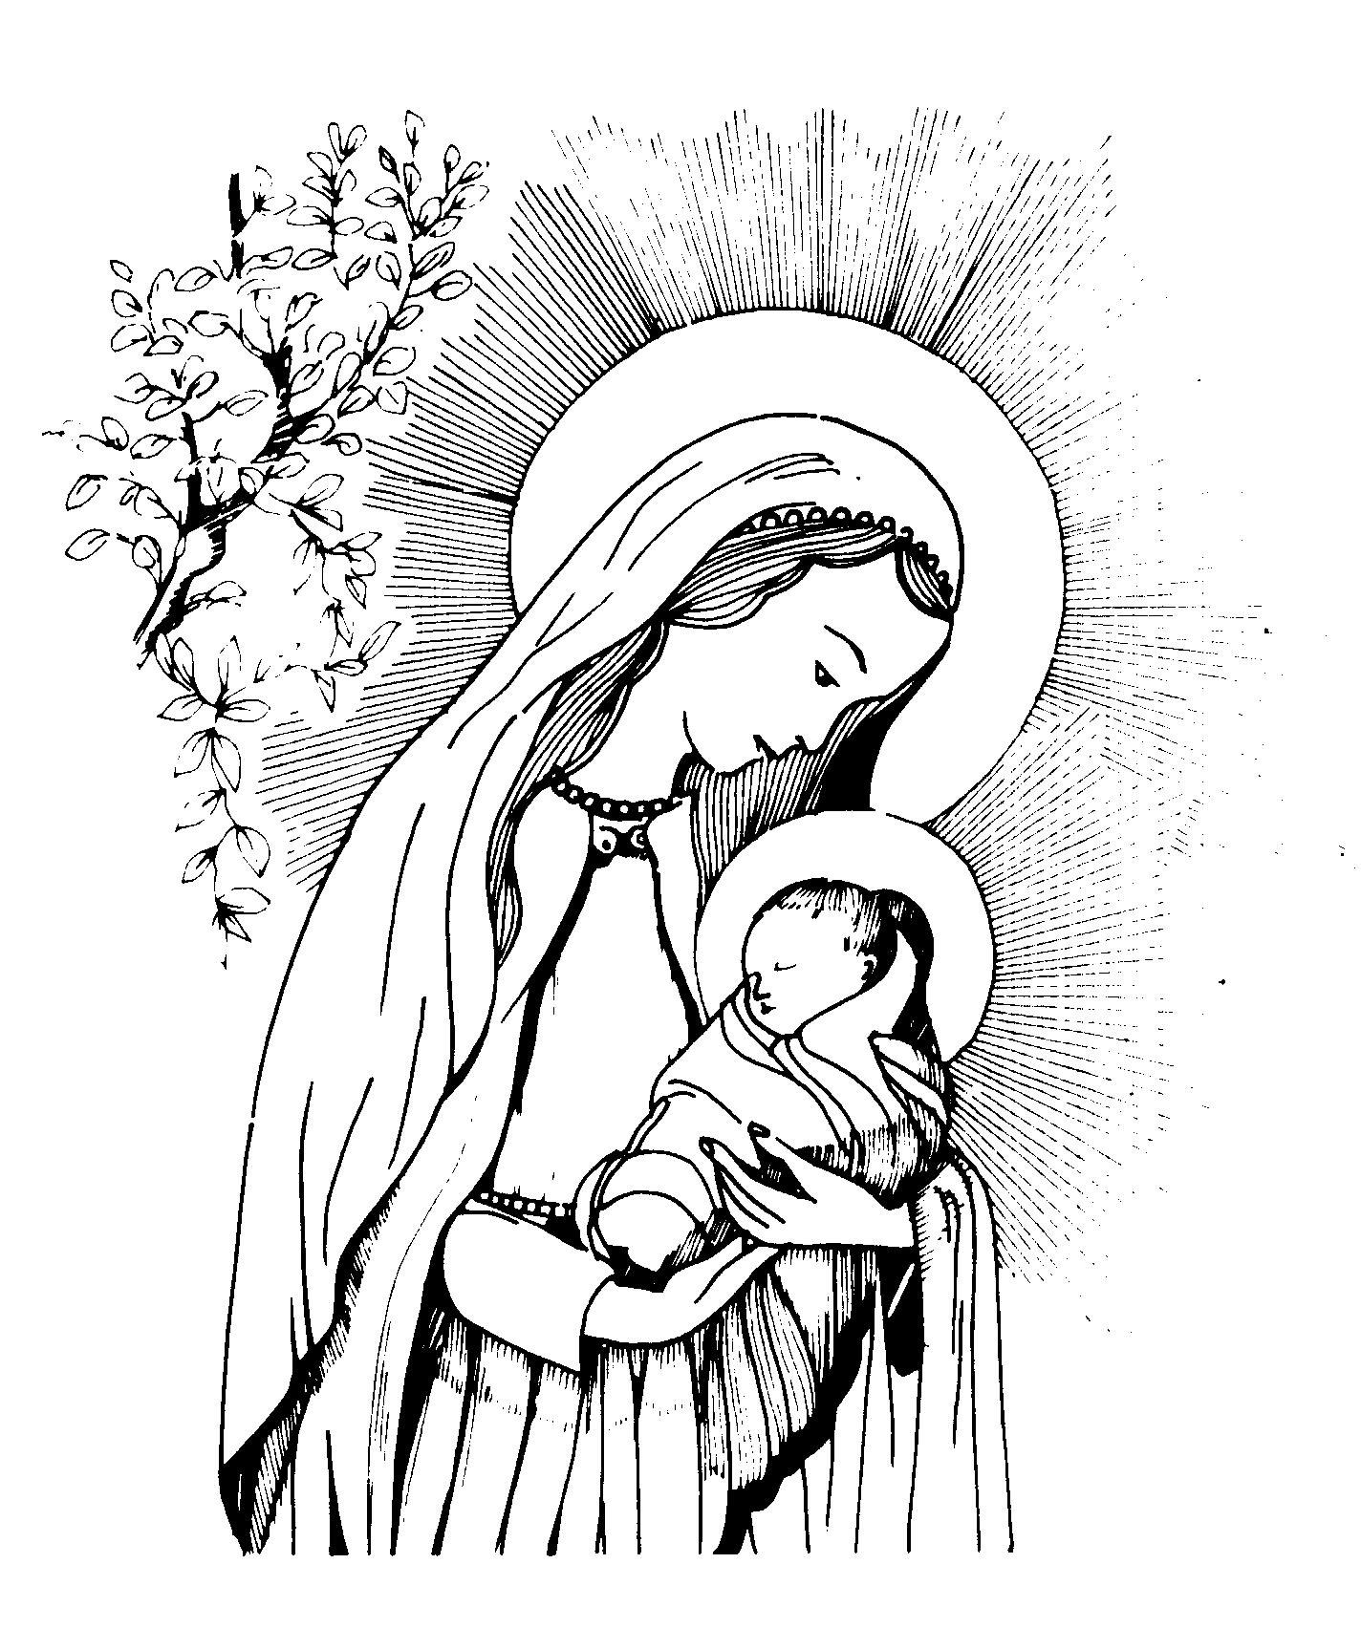

Catholic Primary School & Nursery
Broadway, Derby, DE22 1AU
Headteacher: Mrs A C Greaves
Tel: 01332 554831
Email: admin@stmarys.derby.sch.uk
www.stmarys.derby.sch.uk

HEAD-LICE

For information on the treatment of Head-lice, please use the following link: -

http://www.nhs.uk/Conditions/Head-lice/Pages/Treatment.aspx

