

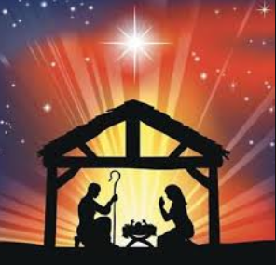

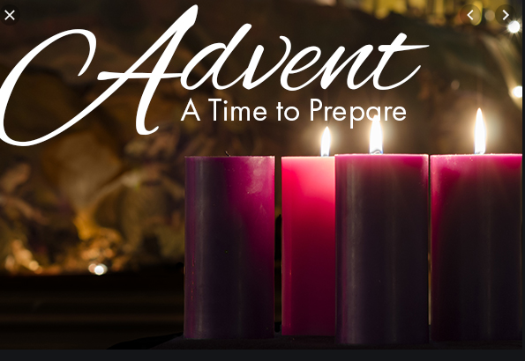

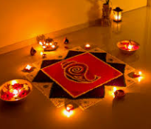

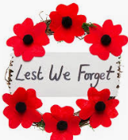

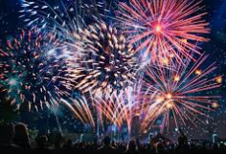

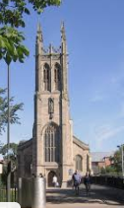



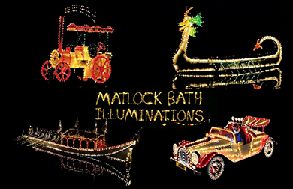

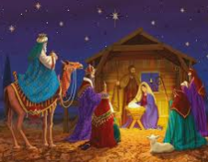

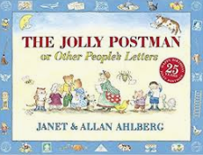

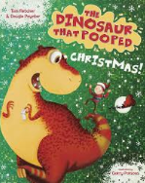

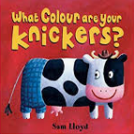

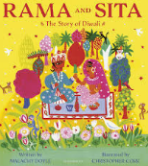

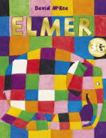

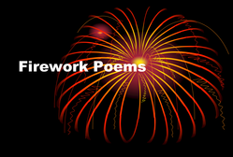



Key Questions

What is a celebration?

Why do we have fireworks?

What noises can you hear?

Who do we remember?

What is Diwali?

What is Advent? What is Christmas?

Places to Visit

Matlock Illuminations

Firework Display

St Mary’s Church

Books

Firework Poems

Elmer

Rama and Sita Story

What Colour Are Your

Knickers?

The Dinosaur that Pooped Christmas

Jolly Postman

Christmas Story

And more along the way …

Key Words Judaism

Colour Bright

Festival Fireworks

Celebrations Advent

Rangoli Diwali

Celebrations and Key Events

Fireworks/Bonfire

Remembrance

Diwali

Advent

Christmas