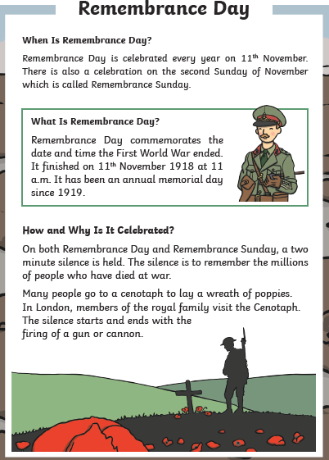  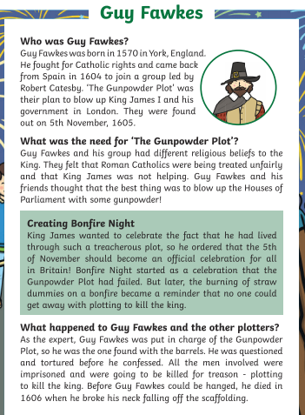  Local link: Go to the National Memorial Arboretum, just 20 miles outside of Derby. The National Memorial Arboretum is the UK's year-round centre of Remembrance; a spiritually uplifting place which honours the fallen, recognises service and sacrifice, and fosters pride in our country. It is a living and lasting memorial. |  | This half term our history focus is on learning about significant events beyond our living memory and we will build on what was previously taught about Remembrance Day and The Gunpowder Plot. It is important for us to recognise the impact of significant events that happened in the past.  Events in history beyond my living memory  Talking point:  Why do you see a guy on the bonfire?  Why do we wear poppies?
Derby link  The Royal Crown Derby Porcelain Company is the oldest oldest remaining English porcelain manufacturer, based in Derby, England. The company, particularly known for its high-quality bone china, having produced tableware and ornamental items since approximately 1750. It was known as 'Derby Porcelain' until 1773, when it became 'Crown Derby'. In 1890, Queen Victoria appointed Crown Derby to be "Manufacturers of porcelain to Her Majesty" and by royal warrant granted them the title "The Royal Crown Derby Porcelain Company". | Based on The Royal Crown Derby company we are going to design, make and evaluate our own salt dough plate. Linking back to our Derby Detective Tour we are going to create a design for our plate that highlights a key feature/ landmark of Derby.  Design and Technology  Talking point:  Why have Royal Crown Derby been so successful?  Try and visit the Visitor Centre and see the range of products made.  How could you make sure your plate is strong and stable?
Key D&T vocabulary
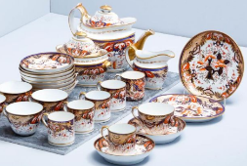
- design
- product
- equipment
- strong/stable
- evaluate
- technical knowledge
KS1 Autumn 2 Knowledge Organiser
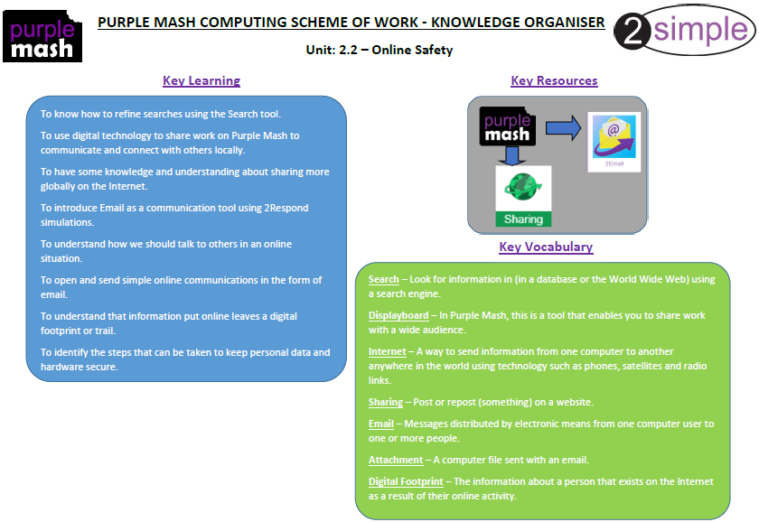  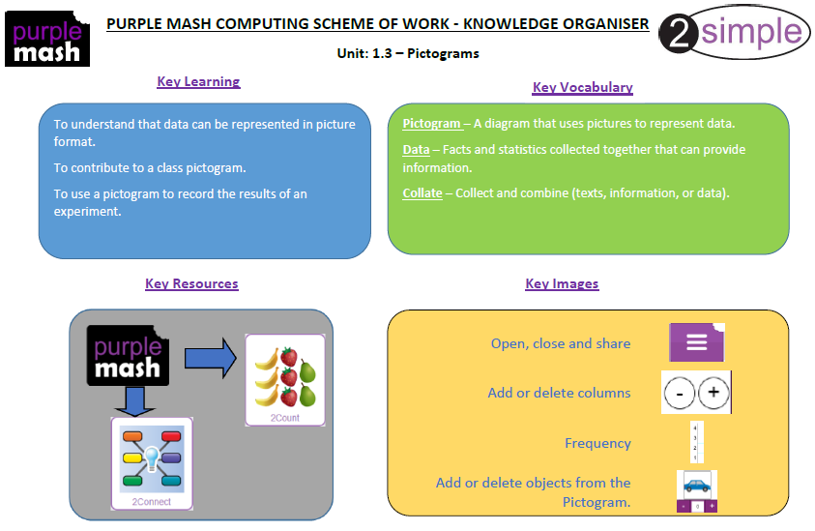  Computing Year 1 |  | 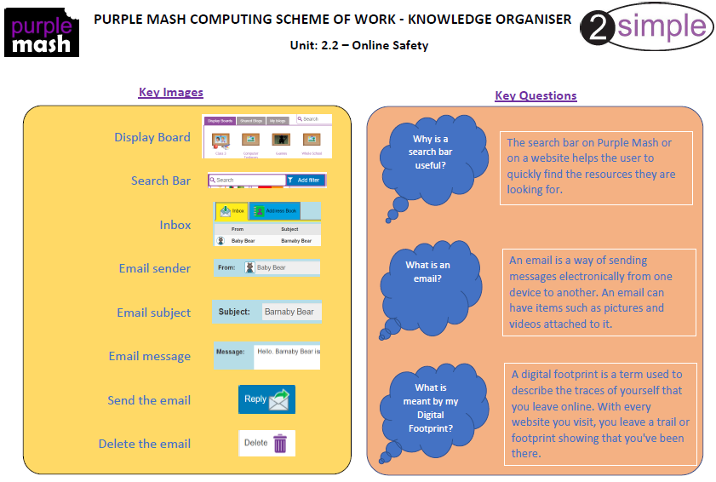  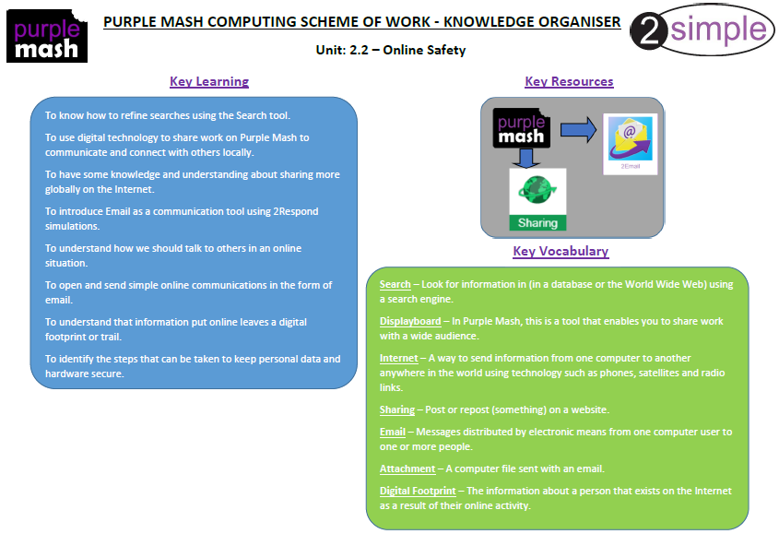  Computing Year 2
Science: Material investigations  We will be using all our knowledge of materials to help us work scientifically. Some of the skills we will be working on include asking simple questions, recognising they can be answered in different ways; performing simple tests; using observations and ideas to suggest answers to questions and finding out how the shapes of solid objects made from materials can be changed by squashing, bending, twisting and stretching. We will start by researching Charles Macintosh and then planning and carrying out a waterproof investigation. We want to investigate which material would be best to make a | 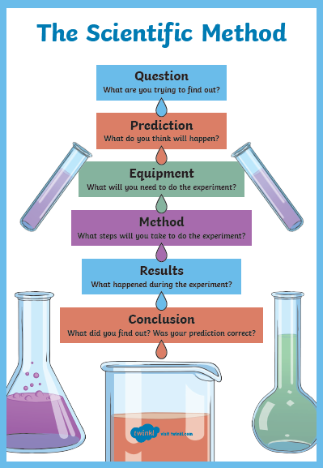  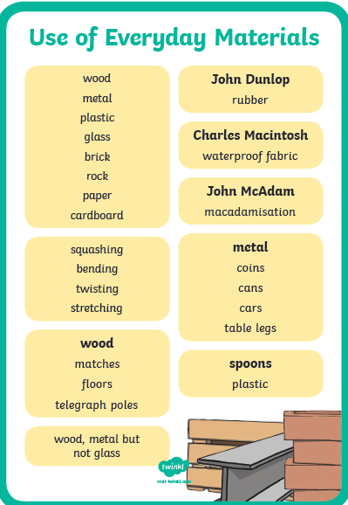  waterproof roof for the three little pigs! We will follow the Scientific Method chart to help us carry out our investigation.  What is Charles Macintosh famous for?  Why is waterproof fabric a good invention?  Talking point:

