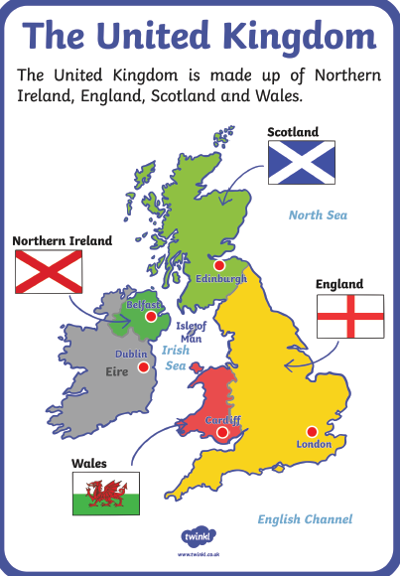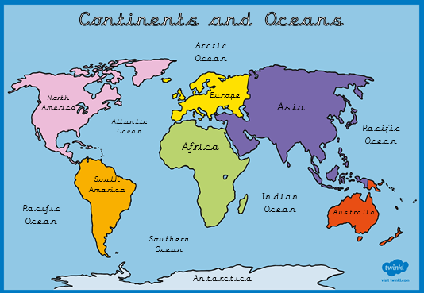Geography

**Key knowledge:**

To learn the 7 continents and 6 oceans, 4 capital cities of the UK and to use this knowledge to identify the places that food comes from around the world (D&T link).

Science

**Key knowledge:** to know that animals including humans, have offspring which grow into adults (we will look at animals found in the UK and those found around the world).

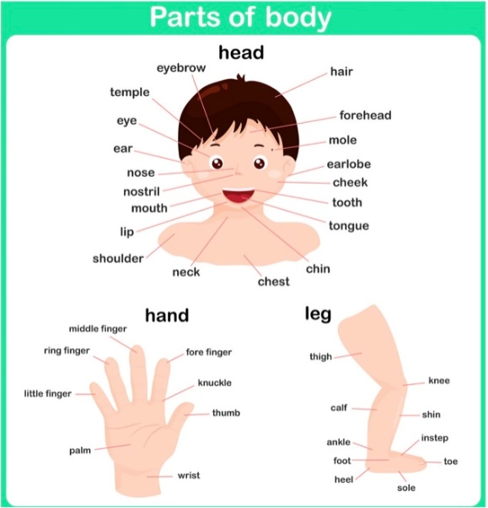**Year 1-** to identify, name, draw and label the basic parts of the human body.

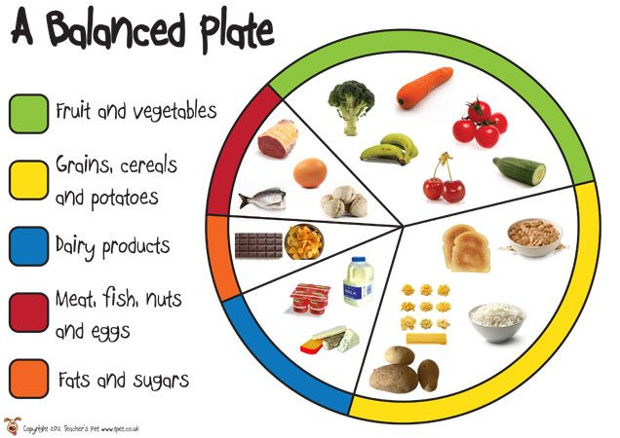**Year 2**- to describe the importance of eating the right amounts of different types of foods (food groups/ healthy plate).

D&T

**Key knowledge:** to understand the basic principles of a healthy and varied diet and understand where food comes from. Please talk about how eating fruit and vegetables helps create a healthy diet and discuss where the food you eat comes from (thinking back to its source or where in the world it is from).

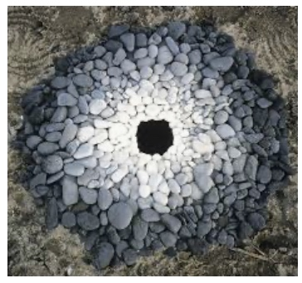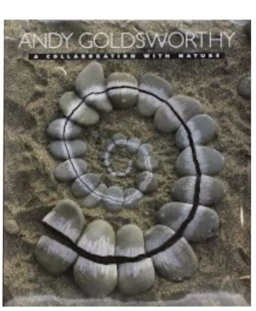Art

**Key knowledge:** Recall the name of the artist Andy Goldsworthy, describe his art sculptures that are made of natural materials, discuss preferences about his work and design one of their own natural sculptures.

Learn about well dressings, which are an ancient custom typically found in Derbyshire and develop their art techniques of using form (something that is three-dimensional) and space by creating their own well dressings.

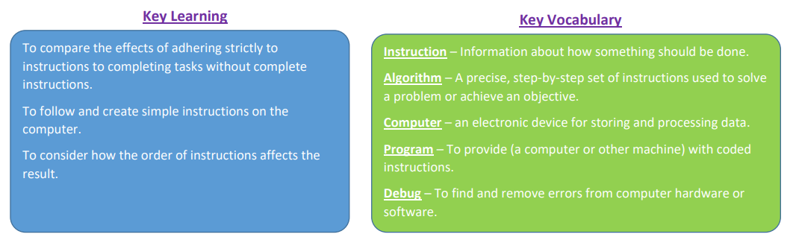Computing

Year 1 –Lego Builders

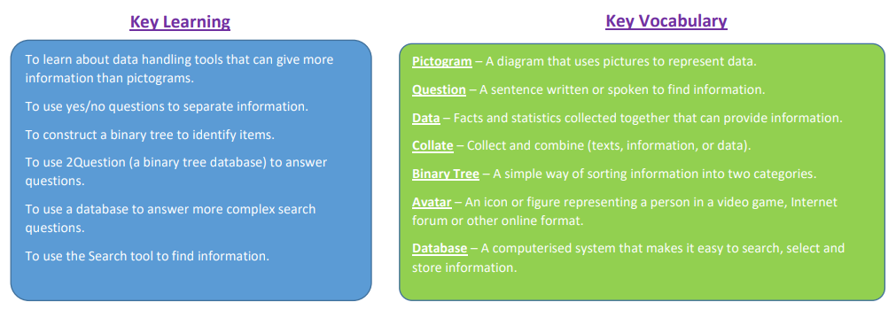

Year 2- Questioning