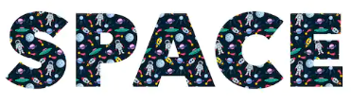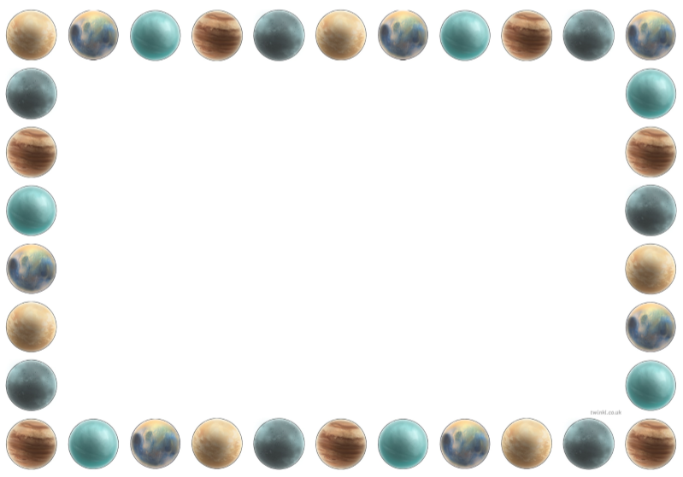

**Key Words**

Planet Star

Astronaut Gravity

Rocket Neil Armstrong

Sun Moon

**Our Solar System**

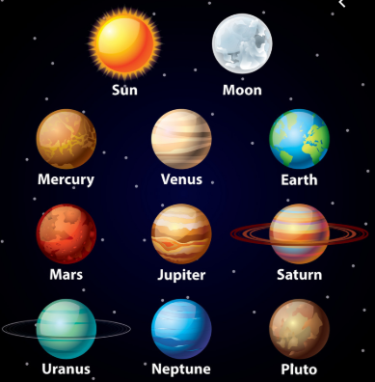

Man on the Moon

Aliens in Underpants Save the World

Laura’s Star

Aliens Love Underpants

Whatever Next

**Our Quality Texts**

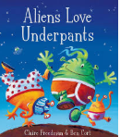

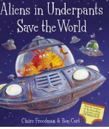

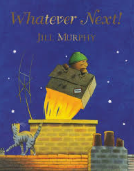

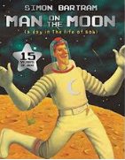

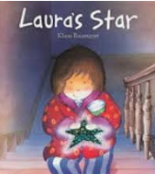

**Key Questions**

Which planet do we live on?

What colour is land and water when you look at Earth from space?

What is an astronaut? Can you name one?

How many planets can you name?

**Useful Websites for you to look at With Your Child.**

<https://www.planetsforkids.org/other/cool-space-facts.html>

<https://www.youtube.com/watch?v=F2prtmPEjOc>

<http://www.sciencekids.co.nz/sciencefacts/planets.html>

<https://www.natgeokids.com/uk/discover/science/space/ten-facts-about-space/>