Design &Technology
D&T Cooking and Nutrition –Bread making project
Design a purposeful, functional and appealing product.

Generate, develop and communicate ideas through talking and making mock-ups.

Make: Select from and use a range of tools and equipment to perform tasks.

Select from and use a range of materials according to their characteristics.

Evaluate their ideas and products against the design criteria.

What do you think you have done well?
What skills do you think you could improve on?

Are you happy with how your work matches your design criteria? Why? Why not?

Key Vocabulary
Design- A plan for the construction of an object
Product – Something that is made to be sold
Evaluation – To study carefully and judge
Improve – To increase the quality or care of something
Design criteria- clear goals that a project must achieve in order to be successful.

ENTERPRISE PROJECT: Big 13 skills
Team Work Risk Negotiating & Influencing
Effective Communication Creativity & Innovation
Positive Attitude Initiative Organisation & Planning
Problem Solving Leadership Making ethical decisions
Financial Literacy Product & service Design
Science
Prior knowledge: In Foundation Stage the children talked about things they observed, such as plants and animals, as well as showing care and understanding for living things in our environment. They also learnt about the importance of a good healthy diet, regular exercise and how to manage their basic hygiene.
Key knowledge: We will be using our investigation skills by grouping, classifying and observing changes over time.
Year 1 - Animals- to learn the terminology used to group animals; Mammals, Amphibians, Reptiles, Birds, Insects, Fish, Arthropod, Molluscs.
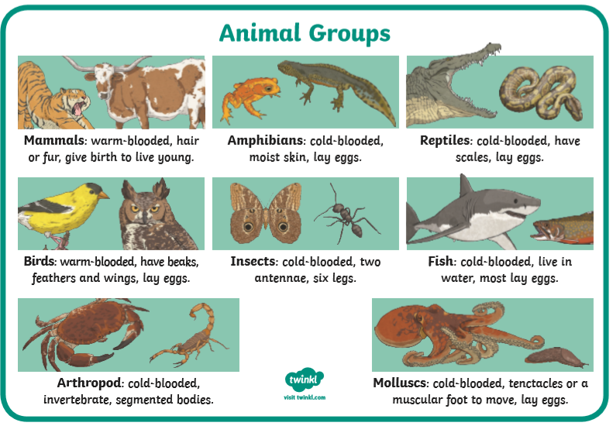
Year 2 - To understand the importance of personal hygiene (teeth and cleanliness) and how to predict, carry out and evaluate an experiment.
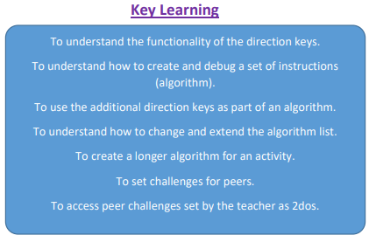
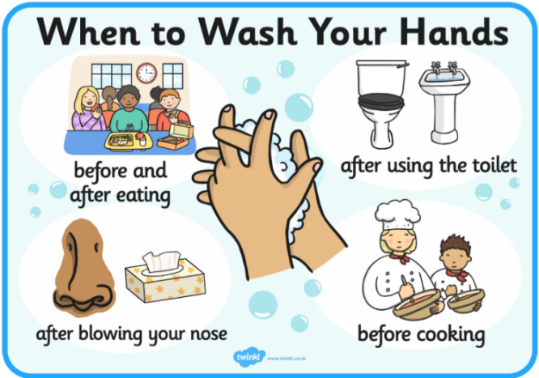
Computing
Year 1 – Maze explorers
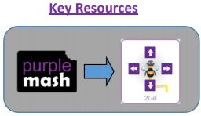
Prior learning: giving a beebot instructions, following directions.
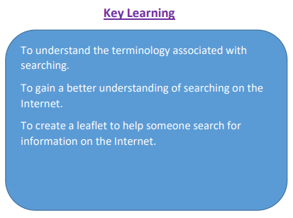
Year 2 – Effective searching
Prior learning: search engine, internet, leaflets

