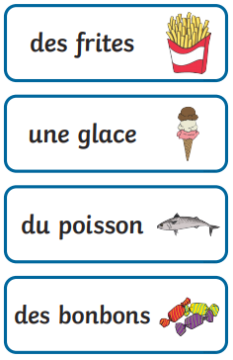Year 6 French Knowledge Organiser– Advent – Food, My Body, Clothes

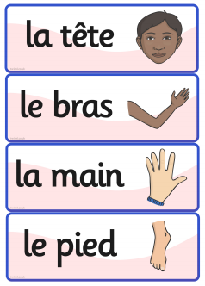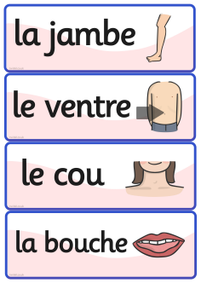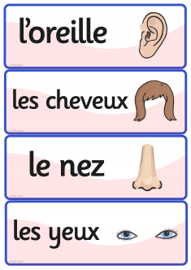

La nourriture (food)

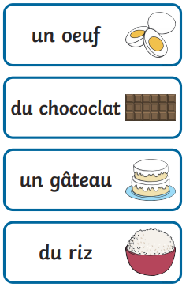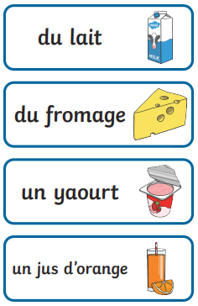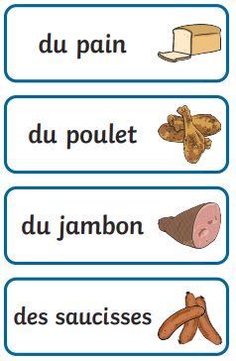

Le corps (the body)

**du chocolat**

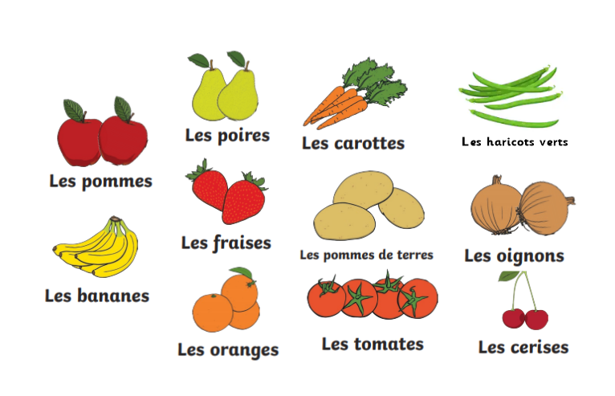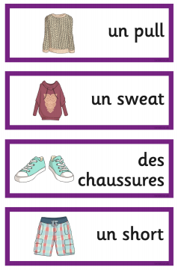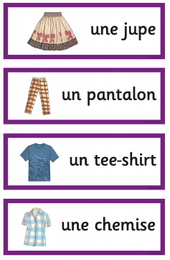

C’est bon pour la santé = It’s good for your health

C’est mauvais pour la santé = It’s bad for your health

fruits et légumes (fruit and vegetables)

The endings of adjectives change to match the noun (masculine/feminine and singular/plural)

e.g. le chien blanc (the white dog)

les chiens blancs (the white dogs)

la souris blanche (the white mouse)

les souris blanches (the white mice)

Grammar

le / un used for masculine nouns e.g. le pied

la / une used for feminine nouns e.g. la main

Les vêtements (clothes)

Prior Knowledge

Colours - Year 3 Pentecost / Year 4 Lent

Numbers 1-100 - Year 4 Advent

I like, I don’t like – Year 4 Lent

Fruit and Vegetables – Year 5 Pentecost

Animals – Year 5 Lent