YEAR 5 ADVENT TERM TOPIC 1  OURSELVES | RE Knowledge Organiser | 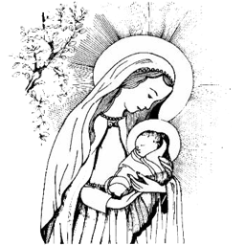
Vocabulary  Responsibility To have a duty to deal with something or of having control over someone  Dignity The state or quality of being worthy of honour or respect  Image A representation of the external form of a person or thing  Peacemaker A person who brings about peace | The Big Question  Who am I ?  Scripture  Genesis 1:26-31  I know that God is a God of love. God created human beings out of love, to continue the work of creation, to be life-givers, not only in the physical sense – but in the way that the gift of life is to be developed, respected, cared for and shared.  Cols 3: 10-11  I know all human beings have been created out of love, in the image of God, and all are called to develop and grow in love for God, and for their fellow human beings.  Cols 3: 12-17  I know this is letter from St Paul’s to the Christians of Colossae. I know about the dignity of every person – each one made in the image and likeness of God and therefore worthy of respect and dignity - “God loves you...has chosen you...a holy people.”; it reminds us that we must treat each other as God treats us – “...generous, gentle and patient...the Lord has forgiven you...you must do the same..” ; I know that I can be encouraged by these words, because even though things go wrong, even though we know we are not perfect, we have all been called by God to do the work of God, to live the Gospel, among our families and friends.  Phil 4: 4-9  I know we are created by God in love, and that this love supports me all through life. I know I am blessed with gifts and qualities for the benefit of myself and others. I know I will experience difficulties and worries like everyone else. In this passage, I am reminded that in the difficult moments, God is holding me with love and concern. For this reason, says Paul,  “Be happy...be joyful – always. God is very near.”  Hosea 11: 1-4  I can reflect on ‘The Footprints’ poem and remember ‘God is very near at all times’ | Important Images  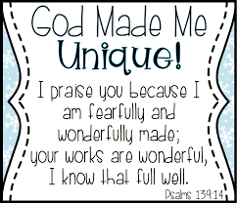  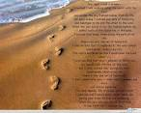  Church Teaching  - Made in the image and likeness of God.  - God as a loving parent.  - Thanksgiving to God.  - God’s children.  - Called to holiness.  - To know, love and serve God.  - Virtue of peace.  - Lives of holy people.

