St Ralph Sherwin Parish serving the churches of St Mary’s, Holy Family & Christ the King
First Reconciliation & Holy Communion Registration Form
[Please return to Fran Hazel at St Mary’s School or The Presbytery by October 31st 2024]

Child’s Name

Date of Birth

Date and place (Church) of Baptism
Name of School

Parents/Carers Names

Address

Telephone Numbers (including mobile if possible)

e-mail

Church you attend

Any other information you feel would be helpful eg allergies, medical needs, mother is non-Catholic/child needs help with reading/spends alternate weekends with other parent
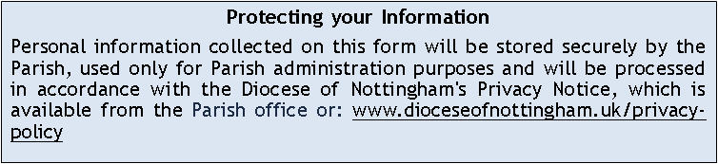

Please turn over…

Photograph Permissions

- I give permission for photos of my child to be displayed at St Mary’s/Holy Family/Christ the King Churches? YES/NO (delete as applicable)

- I give permission for photos of my child to be published on St Mary’s/Holy Family/Christ the King Church websites/social media accounts? YES/NO (delete as applicable)

- I give permission for photos of my child to be published on school social media? YES/NO (delete as applicable)

Privacy Permissions

Your privacy is important to us, and we want to communicate with church members in a way which has their consent and is in line with UK law on data protection. As a result of a change in UK law, we now need your consent to how we contact you.

I consent to the church contacting me by □ phone or □email.

You can withdraw or change your consent at any time by contacting our Parish Administrator at: St Mary’s Church Office, 17 Bridge Gate, Derby, DE1 3AU
or emailing administrator@stmarysparish.co.uk.

