Newspaper writing knowledge organiser (journalistic writing)
Year 5 and 6
What should I already know? | What a good one looks like! | Newspaper writing toolkit
- How to write in chronological order  - Past tense  - Writing in paragraphs  - Formal language    - Recount of events  - Fronted adverbials  - Correct use of person  - Relative clauses  - headlines | 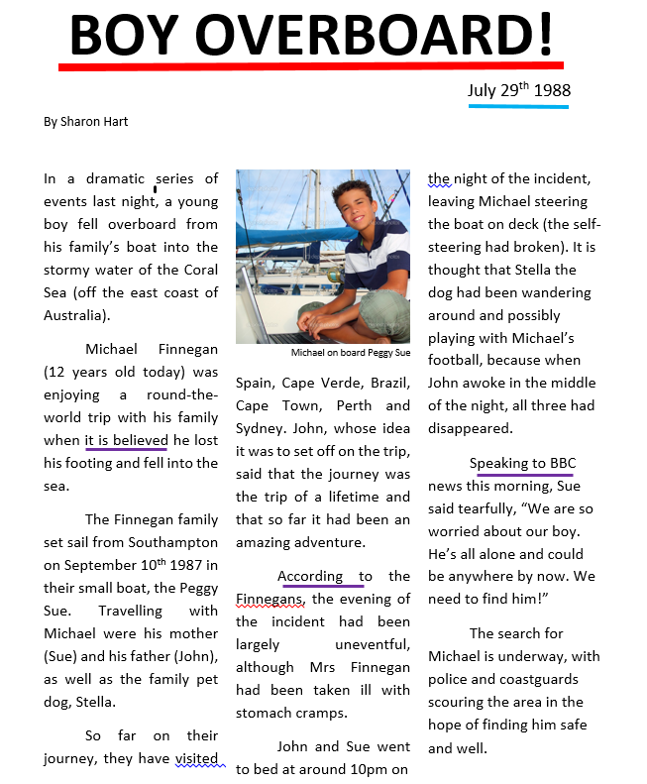  More examples can be found at:  https://www.literacywagoll.com/reports-and-recounts.html | - Headline  - Date  - Chronological order (In time order)  - Formal language  - Direct and reported speech  - Interviews and quotes  - Facts (John and Sue went to bed at 10pm)  - Columns (3 columns on this)  - Orientation (has the 5WS)    - Reorientation (summarises the text)  - Picture and caption  - 3rd person (Michael, the family)  - Past tense
What will I know by the end of this unit? |  | Prior learning
- Writing for a purpose  - Reported speech and direct speech  - Interviews and quotes  - Changes in formality through speech  - Passive and active voice  The police are searching the area (A)  The area is being searched by police (P)  - Relative clauses    - How different newspapers look and why they are reported in certain ways.  - Modal verbs (might, would, could, should etc) |  |   - Newspapers – Santa falls (Y5)  - Newspapers – the 3 pigs (Y3/4)  - Recounts (Y3/4)
 |  | Newspapers – further information
- Derby Evening Telegraph – our local newspaper!
- Newsround – Journalistic writing for children
- Journalist – a person who writes for a newspaper
https://www.bbc.co.uk/newsround

