Poetry knowledge organiser
Year 5 and 6
Poetry structures | What a good one looks like! | Famous poets
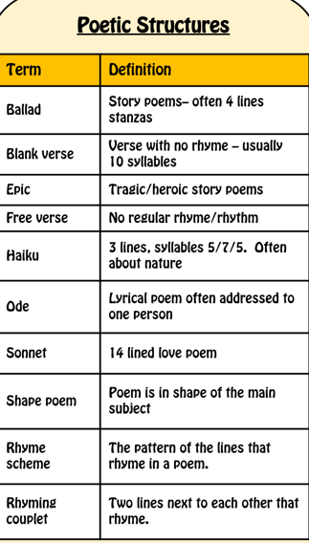 | 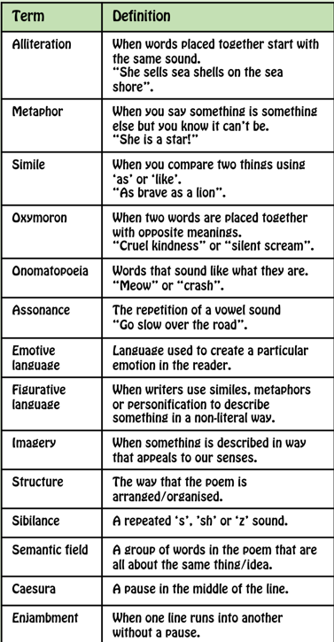There are lots of good examples of poems here:  https://www.literacywagoll.com/poetry.html  Can you find the following? | 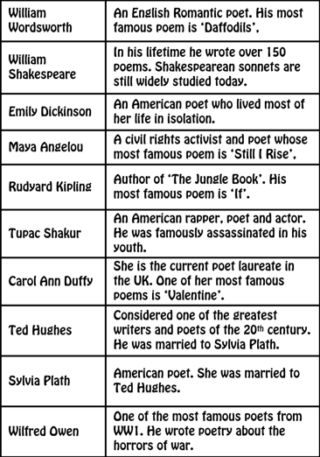
Other reading: |  | Prior learning
Michael Rosen poetry  The children’s poetry archive  The poetry foundation |  | We have covered poetry most years at St Marys and looked at a range of different sentence types, styles and literary features.

