Le café (the café)

Food and drink

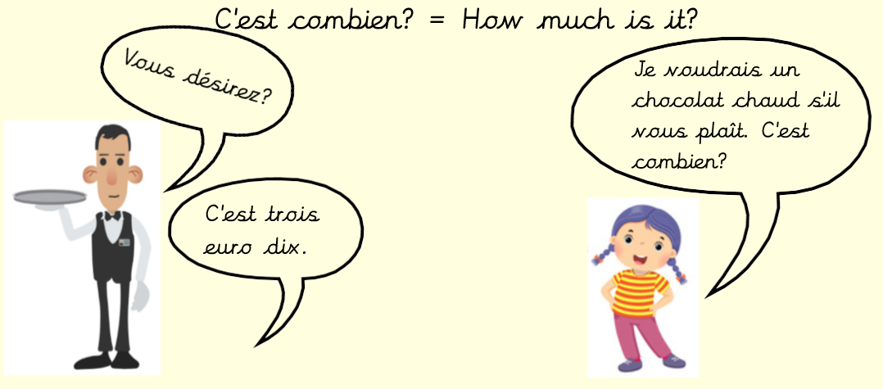
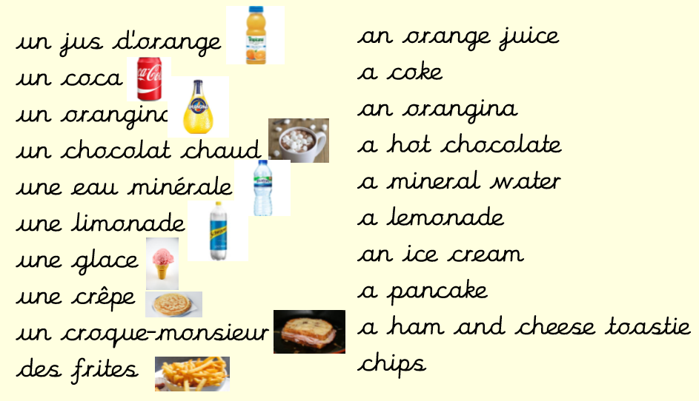

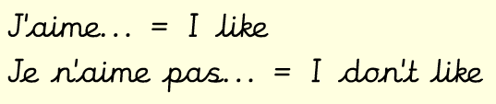
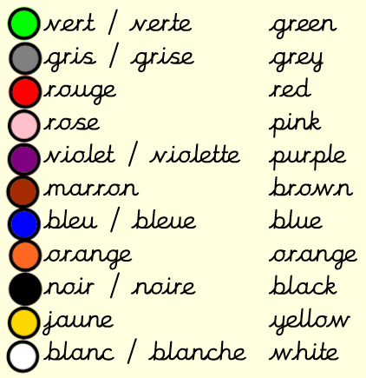
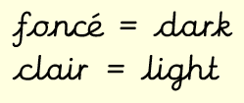
Prior Knowledge
Greetings (Year 3 Advent)
Numbers 1-20 (Y3 Advent)
Colours (Y3 Pentecost)
Grammar
le / un used for masculine nouns e.g. le coca

la / une used for feminine nouns e.g. la glace

Some colours have a masculine or feminine form when used as adjectives.
They must match the gender of the noun. e.g. une pomme verte (a green apple), un haricot vert (a green bean)
Les couleurs (colours)

