Grammar
le / un used for masculine nouns e.g. le pied
la / une used for feminine nouns e.g. la main

Adjectives in French have masculine/feminine forms and must match the noun they describe.
Many adjectives in French come after the noun. Adjectives of size come before the noun:
la planète rouge (the red planet)
la grande planète (the big planet)
Quel temps fait-il? (What is the weather like?)

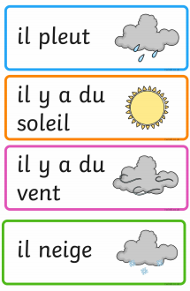
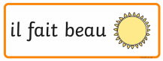

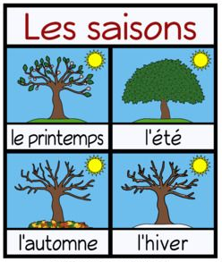
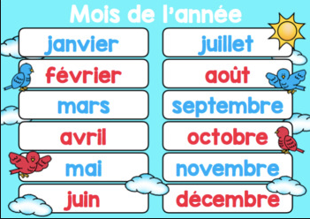
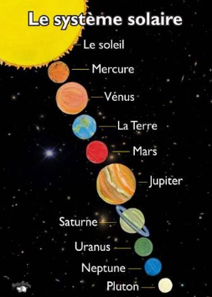
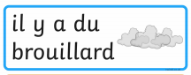
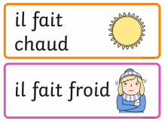
Prior Knowledge
Days of the week – Y3 Pentecost
Colours – Y3 Pentecost / Y4 Lent
Colours – Y4 Lent
French around the world – Y4 Advent
I like, I don’t like – Y4 Lent
Months and Seasons – Y4 Pentecost
au jourd’hui = today

Le système solaire

