Year 1 English knowledge organiser Advent 2021: Narrative Writing – Character and Setting Description
What should I already know? | What a good one looks like! | Writing toolkit:  Setting & Character Description
  - How to form recognisable letters  - How to separate words with spaces  - How to use Phase 2 phonic  knowledge when spelling  - How to spell: to, no, go, the, I  - That a sentence is a group of words  that communicate a whole thought  - How to describe things I can see | 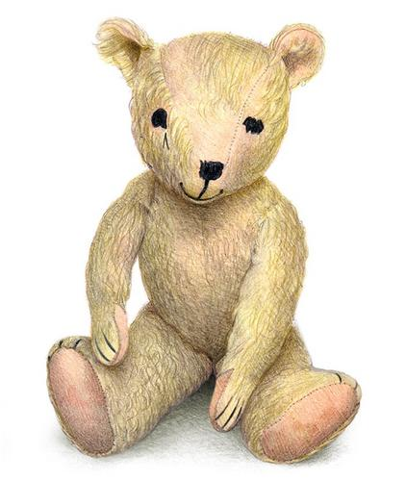  Old bear was the oldest bear in the playroom. His fur was soft but worn. Old Bear’s black and shiny eyes saw everything that was going on.  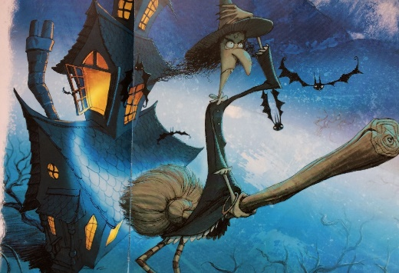  The night was dark and murky. Swirling mist surrounded the old, spooky house. The smell of bonfires hung in the air as yesterday had been Bonfire Night. Rattle clutched her broomstick as she flew through the thick clouds. She grabbed her hat as a screeching bat swooped past. | - Time related opening line  - Descriptive language  - Description using the senses (smell,  taste, hear, sight, sound)  - Joining words using ‘and’  
What will I know by the end of Advent? |  | Prior Learning
  - How to form all 26 letters of the alphabet in a cursive style.  - The name of each letter of the Alphabet.  - That a sentence starts with a capital letter.  - That a sentence ends with a full stop.  - Two different opening lines for stories.  - What an adjective is.  - How to join words using ‘and’  - How to describe a character using adjectives.  - How to describe a setting using the senses.  - How to spell the following words: the, a, to, do. was, is, I. be, he, me, she, we, no. go, by, said, says, his, has, your, they, one, once |  | Writing own Narratives in Reception using the following texts for inspiration:  - Be brave little penguin  - Noah’s Ark  - Five minutes peace  - Sharing a shell  - Lucy and Tom at the seaside
 |  | Good authors for description
Michael Rosen
Helen Cooper
Jill Murphy
Rob Scotton
Julia Donaldson
Janet and Allan Ahlberg

