Year 1 English knowledge Organiser Advent 2025: Traditional Tales
What should I already know? | What a good one looks like! | Writing toolkit:  Traditional Tales
  - How to form recognisable letters  - How to separate words with finger spaces  - How to use Phase 2 phonic knowledge when spelling  - How to spell: to, no, go, the, I  - Know that a sentence is a group of words that communicate a whole thought  - How to describe things I can see | 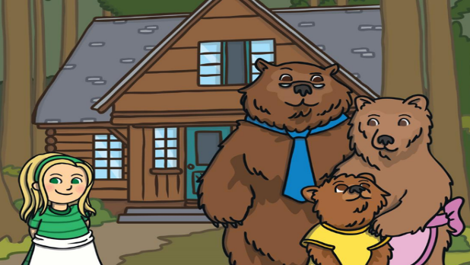  Once upon a time, there lived a little girl called Goldilocks. She was called Goldilocks because she had bright, golden hair.  One day, Goldilocks went for a walk in the forest and found a cute, little cottage.  She knocked on the wooden door, and then she decided to go inside. At the table, there were three bowls of porridge. Goldilocks was hungry.  She tasted the porridge from the large bowl.  “This porridge is too salty!” she said.  She tasted the porridge from the medium-sized bowl. “This porridge is too sweet!” she said.  She tasted the porridge from the small bowl. “This porridge is just right,” she said and she ate it all up.  By now, Goldilocks was very tired, so she went upstairs to the bedroom to have a sleep.  Just then, Goldilocks woke up and saw the Three Bears. “Help!” she screamed. Goldilocks ran down the stairs and into the forest. Goldilocks never went back into the woods again. | Time related opening line - Once Upon a Time, One day…  Descriptive language - adjectives and noun phrases to describe characters and settings  Animals as characters (wolf, bears, goose, pigs)  Setting – (woods, forest, castle, palace)  Joining words using ‘and’    Speech and repeated phrases “This one is too...”
What will I know by the end of Advent? |  | Prior Learning
  How to form all 26 letters of the alphabet in a cursive style.  The name of each letter of the alphabet.  That a sentence starts with a capital letter.  That a sentence ends with a full stop.  What an adjective is.  How to describe a character using adjectives.  How to describe a setting using the senses.  How to join words using ‘and’  How to spell the following words: the, a, to, do. was, is, I. be, he, me, she, we, no. go, by, said, says, his, has, your, they, once |  | Writing own Narratives in Reception using the following texts for inspiration:  - Be brave little penguin  - Noah’s Ark  - Five minutes peace  - Sharing a shell  - Lucy and Tom at the seaside
 |  | Good authors for description
Michael Rosen
Helen Cooper
Jill Murphy
Rob Scotton
Julia Donaldson
Janet and Allan Ahlberg

