Chase story knowledge organiser
Year 5 and 6
What should I already know? | What a good one looks like! | Chase story writing toolkit
- Story writing features    - Beginning, middle, end  - Speech  - Paragraphs  - Range of cohesive devices for sentences and paragraphs  - Building a problem and resolution  - Character and setting description  - Person and tense | Examples of good stories can be found at  https://www.literacywagoll.com/adventure.html  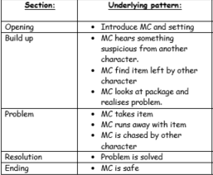Box up grid for chase stories | - Beginning  - Middle  - End  - Paragraphs  - Problem  - Resolution  - Correct person    - Correct tense  - Speech  - Engaging the reader
  Spag/text feature | Example or defintion
  Inverted commas, | The name for speech marks:  “What do you mean?” he asked
  commas, | - Later, she crept through the wardrobe.  - It was a long, winding ride down the rabbit hole.  - It was hard to believe, although he wanted to, that there was another world.
  fronted adverbials, | After a while, he reached the end.
  cohesive devices, | This means to ensure you are using things to help sentences and paragraphs flow effectively. Such as punctuation and a range of sentence lengths and types.
  parenthesis | Adding in extra information using commas, dashes or brackets.
  Show not tell | His brow was sweating and his hands began to tingle This tells me he was nervous rather than just saying ‘ he was nervous’
  Writing for suspense | He finally reached the end of the tunnel, or so he thought …
What will I know by the end of this unit? |  | Prior learning
- Writing for effect  - Writing for suspense  - Show not tell for a range of different emotions  - Effective use of person and tense  - Editing  - Proofreading  - Rewriting |  | - Chase story (Y5)    - Narrative writing (Y4)  - Story writing (Y3)
 |  | Good authors to read for inspiration
Anthony Horowitz
Rick Riordon
Eoin Colfer
Robert Louis Stevenson

And many more

