Persuasive writing knowledge organiser
Year 5 and 6
What should I already know? | What a good one looks like! | Persuasion writing toolkit
- How to structure different writing  - Correct use of tense  - Writing in paragraphs  - Formal language    - Recount of events  - Fronted adverbials  - Correct use of person  - Relative clauses  - Use of facts and statistics | School Election  In the next week, the children of Wellington Primary will be voting for their next school leader. I am writing to tell you why you should vote for me and no one else! Over the coming year, I feel I can make a real difference to each of your lives by caring for and supporting the things that really matter to YOU!  Firstly, I believe that every child should have a longer play time than our current 20 minutes for break and 30 minutes for dinner (excluding eating time). Due to the awful weather, by the time children have put hats, scarves and coats on, break time is almost over! This is simply not good enough! Children need a chance to relax and run around because they have been sat working extremely hard for hours and hours! By making break times longer, pupils will be allowed to burn their energy and will concentrate much better in class than they do now.  Secondly, if I was to be voted in, I would reinvent PE lessons. Currently, most PE lessons are lifeless, outdated and extremely unengaging! There are vast variety of new, thrilling and modern sports such as Ultimate Frisbee, Bungee Jumping and Whitewater Rafting. All of these would make our exercise time much more exciting and would help people keep fit and healthy. Can imagine how happy and smiley children would be if we had roller-skating lessons for PE?  Finally, in order to keep children engaged in the classroom, I propose that teachers scrap their normal school clothes and wear clown costumes instead! Some of the clothes that teachers currently wear are extremely embarrassing. Today, I want to put an end to spotty ties, flowery dresses and silly haircuts! If teachers wore clown costumes, it would make lessons much more entertaining. While we are writing, our teachers can be juggling so our spirits are kept high. In addition to this, when a child is naughty, adults can squirt water at them using the joke flower attached to their crazy coloured jacket.  If you vote for me, you will never regret it. I promise to change school for the better so we can all have more fun! On top of these three main points, I also want to introduce more exciting, dangerous class pets; sword fights in history and a school rollercoaster! If you wish to know more, then please come and find me (Year 5). I will look forward to representing you all after the vote! Vote for me, vote to be free!  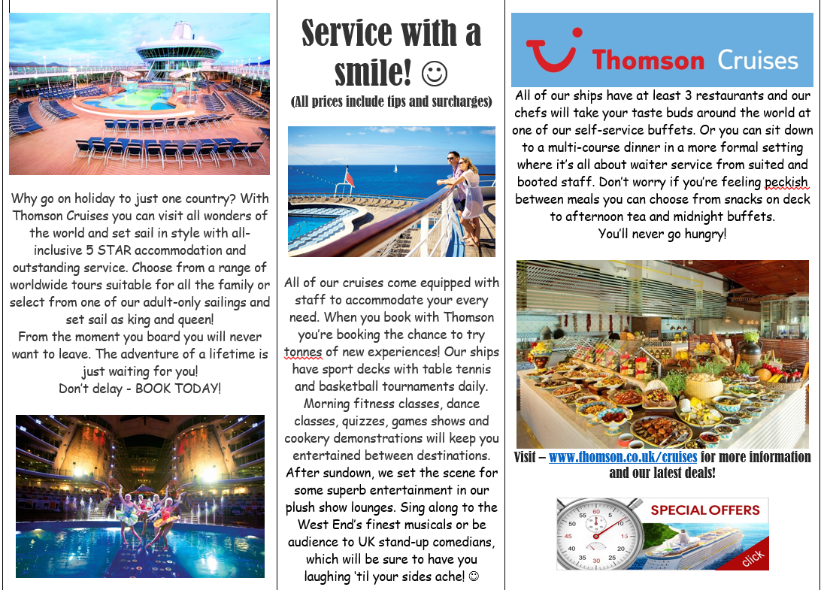 |   Toolkit will vary depending on text types – for example a letter and advert would look different.  Here you can see an example of both!  More examples can be found at:  https://www.literacywagoll.com/persuasive.html  - Exaggeration  - Fronted adverbials  - Rhetoric (wouldn’t you love to take part?)  - Talking directly to the reader (would you like to?)  - Puns and humour  - Informal (adverts)  - Formal (letters or speeches)
What will I know by the end of this unit? |  | Prior learning
- Writing for a purpose (To persuade)  - Reported speech and direct speech (Use of quotes or interviews)  - Interviews and quotes  - Changes in formality (interviews)  - Passive and active voice  The police are searching the area (A)  The area is being searched by police (P)    - How different types of persuasive texts look depending on audience)  - Modal verbs (might, would, could, should etc)  - To use exaggeration to persaude. |  |   First time teaching persuasive writing – persuasion taught in previous years cross curricular through topic (adverts, enterprise)
 |  | Persuasive – further information
Persuasion can take many forms:
Adverts
Letters
Speeches
They all use a lot of the same aspects and really heavily on understanding the audience
https://www.bbc.co.uk/teach/class-clips-video/english-ks1-ks2-how-to-write-a-persuasive-text/zkcfbdm

